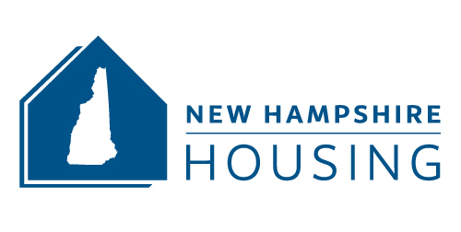

MANAGEMENT AGENT CERTIFICATION OF ANNUAL LIHTC TRAINING

For Calendar Year 20___

Name of Management Company: ____________________________________________________________

LIHTC Training Designation (see website for requirements): _______________________________________

Staff Member Possessing LIHTC Training Designation: ___________________________________________

Date of Low Income Housing Tax Credit Training: _______________________________________________

Name of Nationally Recognized Trainer: _______________________________________________________

Name(s) of staff member(s) attending training: _________________________________________________
_________________________________________________
_________________________________________________
_________________________________________________
_________________________________________________
_________________________________________________

For the previous calendar year, I hereby certify that the above-named management company was in compliance with New Hampshire Housing’s LIHTC Training Requirements. At least one member of the Management Company’s staff possesses one of the approved LIHTC training designations. In addition, at least one staff member has attended at least 6 hours of continuing education during the calendar year.

Note: Failure to complete this form in its entirety will result in noncompliance with program requirements. In addition, any individual other than an owner or general partner of the project is not permitted to sign this form, unless permitted by the state agency.

The project is otherwise in compliance with the Code, including any Treasury Regulations, the applicable State Allocation Plan, and all other applicable laws, rules and regulations. This Certification and any attachments are made UNDER PENALTY OF PERJURY.

Completed by: ____________________________________

Title: ____________________________________________

Signature: ________________________________________

Date: ____________________________________________

